Week 4 – Homework

#**************************

Please see the attached word document for the Homework.

#**************************

Please note all homework is due submitted on-line by 1PM CST (Dallas) on Wednesday September 27. The homework is intentionally less this week to enable you to focus on your project submission.

Please submit an email to [cmaybin@smu.edu](mailto:cmaybin@smu.edu) titled MSDS_8310 - [Last Name] - Week 4 Homework. For example, my submission would be titled MSDS_8310 - Maybin - Week 4 Homework. In the email should be the following (2) attachments containing the answers to the questions below:

* 1 Project Submission per person (even if you are on a team together)
* 1 Word document: Questions 1 , 2 (written answers)
* 1 R File: Question 1, 2 – code

Please keep all written answers short – say no more than 4 sentences.

Note: Please make sure you name your responses as per above and please submit the questions along with your answers. Thanks.

Note2: I believe that we need significantly more explanation on time value. Accordingly, I have not included that subject in these questions – we will pick the subject back up during the next class session.

Regards,

Chad

#************************

Homework Section

#************************

Assignment 1: Prepare project submissions:

* **Project 1 – submission outlines due – Sept 27th:**
  + **Team members** – 1 person is fine, but no more than 4 on a team
  + **Description of project** – must be related to:
    - the measurement of actual economic (meaning data of your choice) data
    - stock market data using the techniques which will be/are presented in this course.
    - OR your choice, but you will need to clear with me first

Example: comparison of model portfolio risk adjusted returns to standard indices (S&P 500).

* + **Defined characteristics and measurement methodology:**
    - Clearly describe what you are:
      * Measuring
      * Predicting
      * And how you will benchmark the success/accuracy of your model
  + **Data sources:**
    - You must be able to access verifiable data both at the inception of the project and ongoing
    - You must have sufficient data to make a quantifiable prediction – data sets should be relatively large and have a dynamic time series element (i.e. changing over the next 3 to 4 weeks). If I can do this in an excel spreadsheet, it is probably not large enough…
  + **Deliverables:**
    - 10 - 15 minutes class presentation which includes the use of Tableau
    - R code workbook showing all relevant code, modeling and reasoning behind comparison of/to benchmarks
    - Brief write-up (2 to 3 pages) of findings: specific format is up to you/team, but at this point in the program you should know how to do this…
* **Project Submissions and Presentation will be due/given during class on Wednesday October 18th.**

Question 1 – Interpreting Demand Curves :

1. The Klein Corporation’s marketing department, using regression analysis, estimates the firm’s demand function, the result being Q = -104 - 2.1P + 3.2I + 1.5A + 1.6Z Rsquared = 0.89 Standard error of estimate = 108 where Q is the quantity demanded of the firm’s product (in tons), P is the price of the firm’s product (in dollars per ton), I is per capita income (in dollars), A is the firm’s advertising expenditure (in thousands of dollars), and Z is the price (in dollars) of a competing product. The regression is based on 200 observations.

a. According to the statistical software, the probability is 0.005 that the t statistic for the regression coefficient of A would be as large (in absolute terms) as it is in this case if in fact A has no effect on Q. Interpret this result.

b. If I = 5,000, A = 20, and Z = 1,000, what is the Klein Corporation’s demand curve? (Graph in R = keep in mind P means “Price”…)

c. If P = 500 (and the conditions in part b hold), estimate the quantity demanded of the Klein Corporation’s product.

d. How well does this regression equation fit the data given the Rsquared value? What additional metrics might be used to compare models?

Allen, W. Bruce; Weigelt, Keith; Doherty, Neil A.; Mansfield, Edwin. Managerial Economics: Theory, Applications, and Cases (Eighth Edition). (Page 125). W. W. Norton & Company. Kindle Edition.

Question 2 – Practical Learning: QSP – Compare statistical output to R:

1. Export CPS1985 data set into excel

library("AER")

data("CPS1985")

…

#Write data to excel

library(xlsx) #load the package

write.xlsx(x = CPS1985, file = "CPS1985_DataDownload.xlsx",

sheetName = "BaseData", row.names = FALSE)

1. In R, create a linear model for wage by Union and Education. Hint: wage_lm <- lm(wage ~ education, data = CPS1985). Then obtain these results on the model.

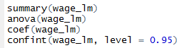

1. Perform same analysis using excel stat package. Are the results the same? If not, what specifically is different? Why does that matter?

Excel steps guide (PC):

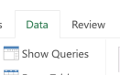

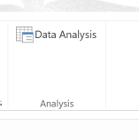

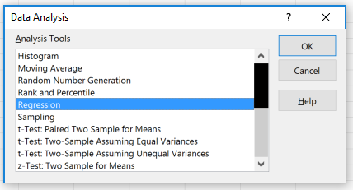

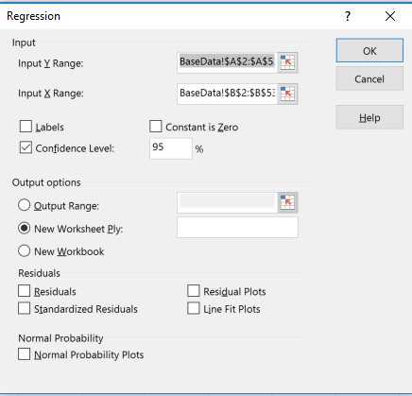

Where data is structured in excel as….

